Date: 06/09/2021 Name: APAR GARG

- A professional photographer has captured the following 16 grey-level image (Fig. 1) at night. The image contains a bright house on the left (those pixels with grey levels ≥ 8) and the moon on the right (those pixels with grey level ≤ 6 and ≥ 2).
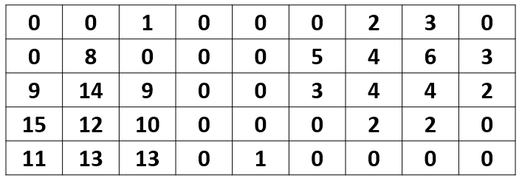
Fig. 1.
- Establish the histogram of this image by describing and listing down the respective values on each column.
Gray Value | Frequency
0 | 21
9 | 2
15 | 1
11 | 1
8 | 1
14 | 1
12 | 1
13 | 2
1 | 2
10 | 1
5 | 1
3 | 3
2 | 4
4 | 3
6 | 1

- Design a point processing method (with diagrams and/or flow chart) to keep the grey level of those pixels representing the moon unchanged, and transform the house and background to black.
Keep 2 thresholds T1 = 2, T2=6
If pixel p < T1 or p>T2:
Then p = 0
Else:
Keep p same

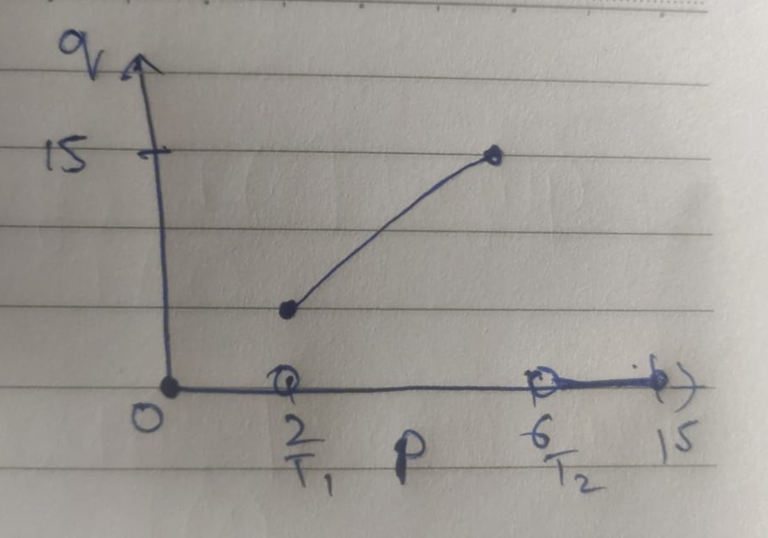

- Establish the histogram after inverting (negative) the image produced from (b) above.
P=15 -p
Gray Value | Inverted Gray value | Frequency
0 | 15 | 33
2 | 13 | 4
3 | 12 | 3
4 | 11 | 3
5 | 10 | 1
6 | 9 | 1

- You are a radiologist working in a screening department to study the CT-images of the torso to identify any abnormalities. More often than not, the images obtained are not ideal like the one in Fig. 2 below. Identify what is/are its quality issue(s) and propose an image processing approach to address it.
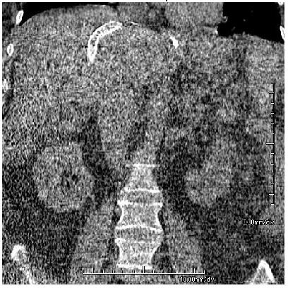
Fig. 2.
Problem - Background and Foreground gray values are very similar. So there are no proper boundaries and shape. Too much noise. No proper Contrast.
Solution – To reduce noise we can use Image Avging/Median Filter/Histogram Eq.

- You are a MTech student who has just completed the lectures under Dr Matthew Chua. For your entrance interview test to become a hospital radiomics specialist (a specialized professional in the application of image processing and artificial intelligence in micro-detail analysis of medical images), you were presented an image of a retina (Figure 3(a)). The end state image, which consists of the retina vessels, is presented in Figure 3(b).
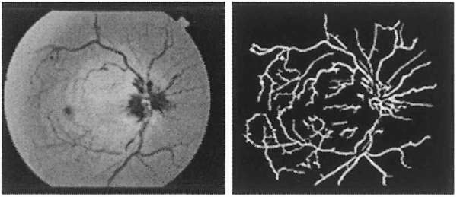
Figure 3 (a) Initial image of the retina and (b) final image of the retina vessels.
Answer the following questions:
- Devise an image processing approach to achieve Figure 1(b) from Figure 1(a).
Step 1 – Perform 2 pass segmentation to label the black edges pixels around the border as B (Detect black background outside retina).
Step 2 - Single pass to change black pixels B to white 255. (Convert black background to white).
Step 3 – Single pass binary thresholding to convert pixels above threshold T to black and below T to white.

- Discuss the various ways to quantify the image in Figure 1(b) in order to further analyze it to detect potential medical conditions.
Interconnectivity of vessels - No. of white pixels connected in a neighborhood.
Level of branching from the main branch
Centroid of vessel
Length of the vessel

- You have been hired by Peter Jackson, a famous film producer, to be the lead digital image engineer in his company. He is currently working on a new film called “They Shall Not Grow Old”, which essentially is a processing of grey-scale World War II documentaries into a modern movie with colours (Figure 4 and 5). He has put you in charge of this project. Answer the following questions:
  - From the inspection of the original films, state what issue do you observe and the method to improve it.
Issue - No proper contrast and boundaries in the documentary. Hard to detect objects. Too much noise.

Solution – Smoothening to remove noise -> Sharpening to highlight objects.

  - Propose how you would approach this project to deliver the movie that he desires.
Class segmentation of different objects (tree, human etc.) because
each object will have color scheme of its own.

Assign color to objects.

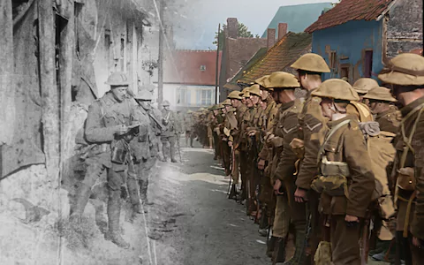
Figure 4. (Taken from https://www.telegraph.co.uk/news/2018/01/22/peter-jackson-brings-first-world-war-life-stunning-new-film/)
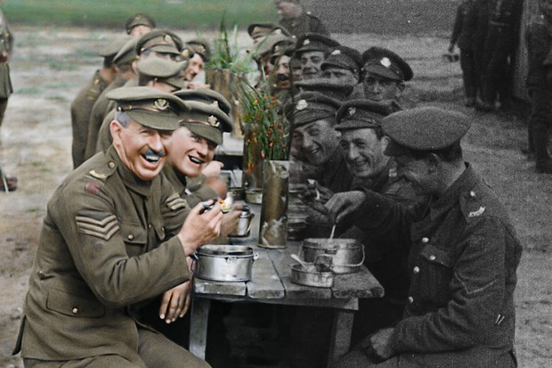
Figure 5. (Taken from https://www.radiotimes.com/news/tv/2018-10-31/bbc2-air-date-revealed-for-peter-jackson-first-world-war-film-they-shall-not-grow-old/)

